# Contents

Data Analytics Project: Marketing Campaign Effectiveness Analysis 2

I. Dataset Description 2

II. Data Preparation 3

III. Data Exploration 3

IV, Data Analysis and Insights 3

1, Executive Dashboard 3

a, Multirow Cards: Key Campaign Metrics 3

b, Slicer: Campaign Periods (During Campaign & Post Campaign) 4

c, Line Charts: Sales and Quantity Trends 4

d, Matrix: Top 50 products 5

e, Clustered Bar Chart: Quantity Sold by Categories 5

2, Customer Interaction Analysis 5

a, Overall Data (All Campaign Status): 6

b, Channel Analysis: 6

c, Interaction Type Analysis: 6

d, Customer Segment Analysis: 7

d, Interaction Trends Over Time: 7

3, Customer Sales Analysis 7

a, Conversion Rate 8

b, Sales Trends by Month 8

c, Top 100 Customers 8

d, Customer Segmentation Analysis 8

V, Conclusion 8

# List of Figures.

Figure 1. Multirow Cards 4

Figure 2. Time-period Filter 4

Figure 3. Line Charts 4

Figure 4. Top 50 products 5

Figure 5. Product categories performance 5

Figure 6. Customer Interaction Dashboard 6

Figure 7. Customer Sales Dashboard 7

# Data Analytics Project: Marketing Campaign Effectiveness Analysis

This data analytics project aims to evaluate the effectiveness of a recent marketing campaign by a company, which ran from **January 1, 2024 to April 30, 2024**. Utilizing a comprehensive dataset, we will analyze customer engagement, conversion rates, sales impact, and return on investment (ROI). The project will also explore demographic insights to identify key segments that responded positively or negatively to the campaign.

## I. Dataset Description

This dataset contains data from **January 1, 2024 to July 6, 2024**, and includes three main tables with the following structures:

* **Customer Interaction Data (customer_interactions.csv)**
* **Customer ID**: Unique identifier for each customer.
* **Interaction Date**: Date when the customer interacted with the campaign materials.
* **Interaction Type**: Type of interaction (click, view, share).
* **Interaction Channel**: Medium through which the interaction occurred (email, social media, website).
* **Sales Data (sales_data.csv)**
* **Transaction ID**: Unique identifier for each transaction.
* **Transaction Date**: Date of the transaction.
* **Customer ID**: Unique identifier for the customer making the purchase.
* **Product ID**: Unique identifier for each product.
* **Product Category**: Category of the product purchased.
* **Sales Amount**: Total amount spent during the transaction.
* **Quantity**: Number of products purchased.
* **Customer Demographic Data (customer_demographic_data.csv)**
* **Customer ID**: Unique identifier for each customer.
* **Age**: Age of the customer.
* **Gender**: Gender of the customer.
* **Location**: Geographic location of the customer.
* **Income Level**: Income bracket of the customer.
* **Additional Data**
* **Targeted Customers**: 1,500
* **Expected Conversion Rate**: 35%
* **Current Campaign Budget**: $50,000
* **Previous Campaign Budget**: $57,000
* **Previous Sales Revenue**: $268,009

## II. Data Preparation

* In this section, we processed the data through the following steps:
* **Handling Missing Values**: In the **customer_interactions** dataset, there were 11 null values in the **Interaction Channel** column, which were replaced with the mode, **website**.
* **Removing Duplicates**: Ensured that there were no duplicate entries in the datasets.
* **Transforming Formats**: Converted relevant columns, particularly date-related columns, into usable formats.
* **Table Relationships**: Defined the relationships between the tables to enable accurate analysis.
* Overview of Table Relationships: **Linking Tables via Customer ID**
* **customer_interactions** and **sales_data**: Both datasets include the **Customer ID**, allowing us to analyze interactions that lead to sales.
* **sales_data** and **customer_demographic_data**: The **Customer ID** in both tables facilitates the identification of demographic characteristics of customers who made purchases.

## III. Data Exploration

In this section, we explored and analyzed the data to identify key metrics necessary for the report, and the following metrics represent totals for both the campaign and post-campaign periods.

* Calculated Metrics:
* **Total Sales**: $1,945,875.30
* **Average Sales per Customer**: $2,966.27
* **Quantity Sold**: 7616 units
* **Interacted Customers**: 1000 customers
* **Purchased Customers**: 656 customers

## IV, Data Analysis and Insights

This section analyzes the data visualized across three key pages in Power BI: Executive Dashboard, Customer Interaction, and Customer Sales.

### 1, Executive Dashboard

This page provides a comprehensive overview of campaign performance, highlighting key metrics such as total sales, quantity sold, return on investment (ROI), sales trends, and top-selling products. Below is a detailed breakdown of the dashboard's components:

#### a, Multirow Cards: Key Campaign Metrics

* **Recent Campaign Revenue: $1,308,551.48**

This card shows the total revenue generated during the recent campaign.

* **Recent Campaign Profit: $1,258,551.48**

This metric displays the overall profit made during the recent campaign, indicating the financial success of marketing efforts.

* **ROI of Recent Campaign: 2517.10%**

A very high return on investment, suggesting that the campaign was highly efficient in converting the campaign budget into profit.

* **Previous Campaign Revenue: $268,009.00**

This card shows the revenue from the previous campaign, providing a basis for comparison with the recent campaign’s result.

* **Previous Campaign Profit: $211,009.00**

Profit made during the previous campaign.

* **ROI of Previous Campaign: 370.19%**

The previous campaign had a much lower ROI than the recent campaign, indicating substantial improvement in campaign efficiency.

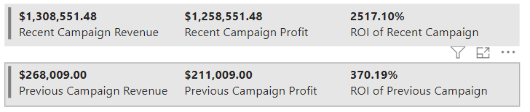

Figure 1. Multirow Cards

#### b, Slicer: Campaign Periods (During Campaign & Post Campaign)

**Time-period Filter:**

* The slicer allows users to switch between data views for two periods: **During Campaign** and **Post Campaign**. This functionality enables decision-makers to evaluate how performance changed after the active campaign ended and identify trends for future strategy improvements.

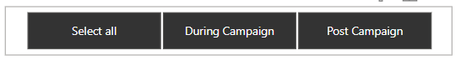

Figure 2. Time-period Filter

#### c, Line Charts: Sales and Quantity Trends

* **Revenue Trending:** The line chart visualizes revenue over time, indicating that sales peaked in April but showed a significant drop starting in May and further declined in June and July. This suggests that April was the most successful month during the campaign, potentially due to specific marketing activities.
* **Sales Quantity Over Time:** This line chart tracks the number of items sold over time, revealing a similar trend to revenue. Sales quantities peaked in April but started declining afterward. This could indicate reduced customer engagement after April or changes in promotional strategies.

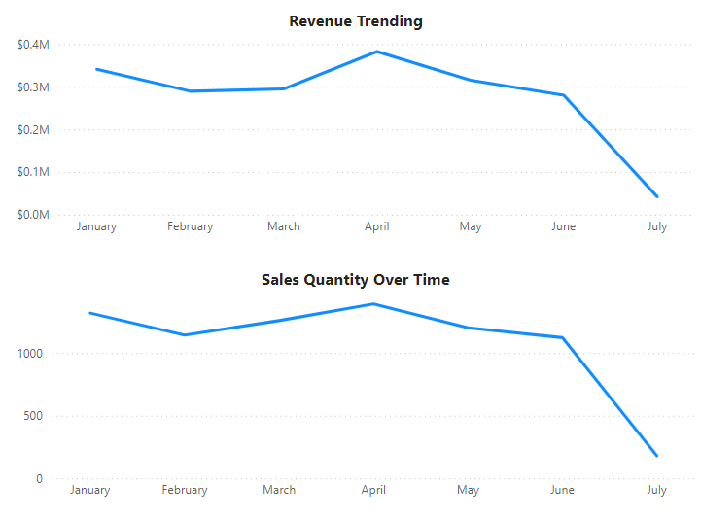

Figure 3. Line Charts

#### d, Matrix: Top 50 products

* The matrix lists the top 50 products, sorted by quantity sold, with corresponding recent campaign revenue and post-campaign revenue.
* Product ID 218 has sold 42 units, generating the highest revenue among all products, with $11,596.75 during the recent campaign and $3,621.00 in post-campaign revenue.
* The total quantity sold across all top products is 1,677 units, generating $358,673.95 during the recent campaign and $163,367.45 in post-campaign revenue.

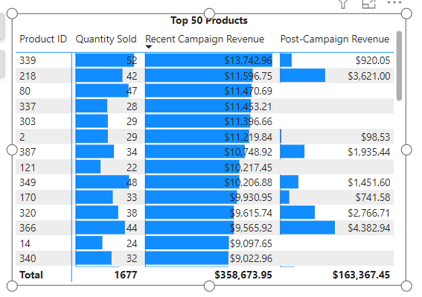

Figure 4. Top 50 products

#### e, Clustered Bar Chart: Quantity Sold by Categories

**Product categories performance:**

* This chart highlights the number of products sold in different categories. Electronics led with 1,414 units sold, followed by Clothing (1,322 units), Books (1,290 units), and Toys (1,263 units).
* These categories likely contributed significantly to the overall campaign's success, particularly Electronics and Clothing, which appear to be the most popular among customers. Electronics leads in sales with $373,185.57, while Clothing sales are slightly lower than Books, at $326,741.17 compared to $340,115.20, respectively.
* Each category includes a tooltip that provides additional insights:
* Total Sales: Displays the total revenue generated for each category.
* Weekly Quantity Sold: A line chart that visualizes the quantity sold every week, allowing for easy identification of trends and peak sales periods.

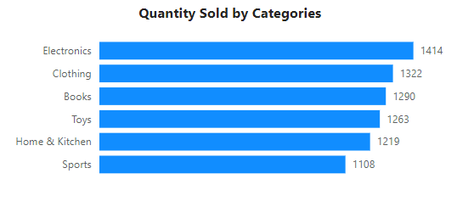

Figure 5. Product categories performance

### 2, Customer Interaction Analysis

This report analyzes customer interactions from **January 1, 2024, to July 6, 2024**, with an added focus on **Campaign Status**, which allows us to differentiate between interactions during the campaign and outside the campaign period. The interactive charts have been updated to reflect this additional dimension, while still providing insights into the overall interaction channels, types, and customer segments.

The analysis is based on three main customer types:

* **Young Low-Income (18–24, <$30,000)**
* **Young Middle-Income (18–24, $30,000-$75,000)**
* **Middle-aged High-Income (>24, >$75,000)**

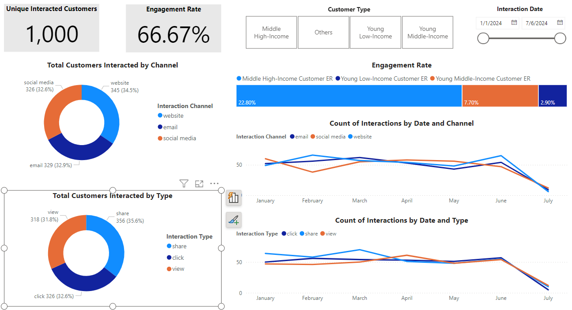

Figure 6. Customer Interaction Dashboard

#### a, Overall Data (All Campaign Status):

* **Total number of interacted customers:** 1,000
* **Engagement rate:** 66.67%

**Analysis:**

* The overall interaction data for the entire time range indicates a **66.67% engagement rate** across all customer segments and channels. This demonstrates good engagement but doesn't yet distinguish between campaign effectiveness and post-campaign interactions.

#### b, Channel Analysis:

**Percentage of customers interacting by channel:**

* **Website:** 34.5%
* **Email:** 32.9%
* **Social Media:** 32.6%

**Analysis:**

* The distribution of customer interactions across channels remains balanced, with **website** leading slightly at 34.5%. The relatively equal share of **email** and **social media** suggests diversified outreach and customer engagement efforts.
* The **website** channel typically serves as a primary destination for more in-depth interactions, while **email** and **social media** likely focus on customer acquisition and engagement.

#### c, Interaction Type Analysis:

**Percentage of interactions by type:**

* **Share:** 35.6%
* **Click:** 32.6%
* **View:** 31.8%

**Analysis:**

* **Share** dominates with 35.6%, suggesting that customers are engaged enough to distribute content within their networks, amplifying the reach of marketing efforts.
* The nearly balanced levels of **click** and **view** interactions indicate that customers are equally driven to engage with content (click) and consume information (view).

#### d, Customer Segment Analysis:

The slicer for **Customer Type** provides a breakdown of engagement rates for different customer segments:

* **Young Low-Income (18–24, <$30,000):** 7.7% engagement rate
* **Young Middle-Income (18–24, $30,000–$75,000):** 2.9% engagement rate
* **Middle High-Income (>24, >$75,000):** 22.8% engagement rate

**Analysis:**

* The **Middle High-Income** segment exhibits the highest engagement rate (22.8%), suggesting this group is more responsive to campaigns or content.
* The **Young Low-Income** group, while having a lower engagement rate (7.7%), still contributes meaningfully to interactions.
* The **Young Middle-Income** group shows the lowest engagement rate (2.9%), which may require targeted strategies to increase their engagement levels.

#### d, Interaction Trends Over Time:

The interaction trends show a notable peak at the end of June, followed by a slight decline in early July. This pattern is reflected across different channels and types of interaction.

**Analysis:**

The significant increase in interactions in June may be attributed to a specific campaign or event that captured customer attention. However, the subsequent slight decrease in early July suggests the end of the campaign phase, highlighting the importance of maintaining momentum and planning new content immediately after the campaign concludes to retain customer engagement.

### 3, Customer Sales Analysis

This report analyzes the customer behavior and revenue generation throughout the campaign and post-campaign periods. The customer types are divided into three groups: **Young Low Income**, **Young Middle Income**, and **Middle High Income**. The data spans both **during the campaign (January–April)** and **post-campaign (May–June/July)** phases, offering insights into how each customer segment responded to the marketing efforts.

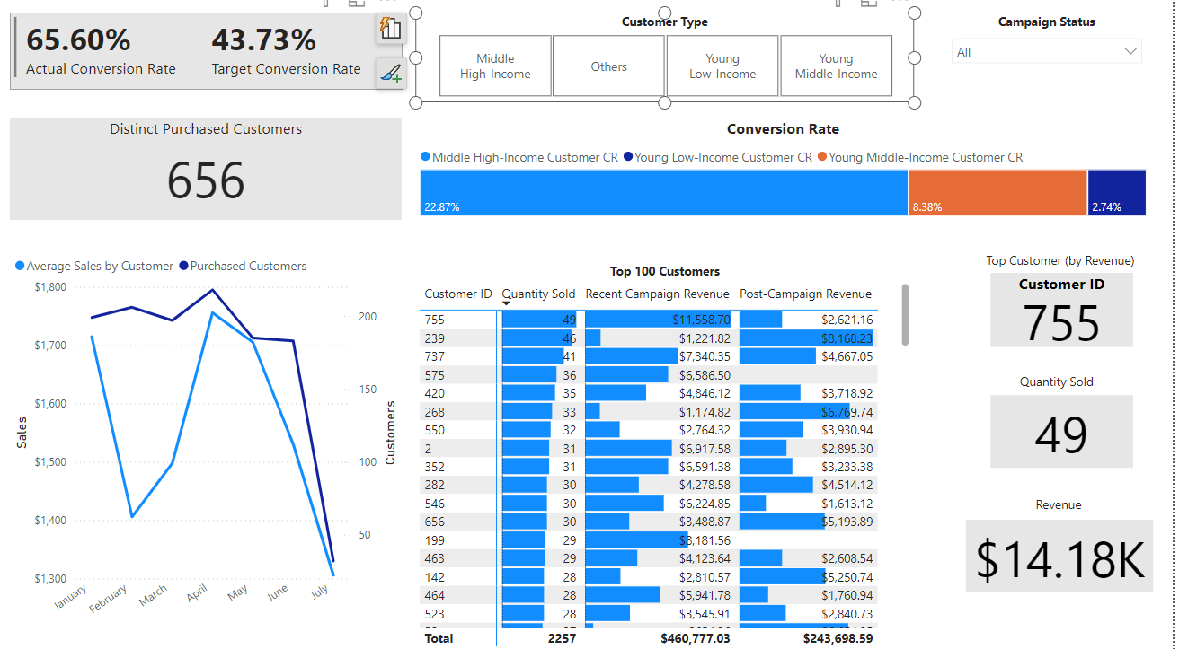

Figure 7. Customer Sales Dashboard

#### a, Conversion Rate

* **Actual Conversion Rate:** 65.60%, surpassing the target of 43.73%, indicating strong campaign performance.
* **Conversion Rate by Customer Segment:**
  + **Middle High Income:** This group had the highest conversion rate of **22.87%**, making them the most responsive segment.
  + **Young Low Income:** The lowest conversion rate at **2.74%**, showing minimal engagement from this group.
  + **Young Middle Income:** Achieved a conversion rate of **8.38%**, performing moderately better than the low-income group.

The high-income group dominates in terms of conversion, while younger and lower-income segments show less engagement.

#### b, Sales Trends by Month

* **Average Sales by Customer:** The highest average sales occurred in **April**, peaking near **$1,800**, but there was a sharp decline in sales post-campaign in May and June.
* The number of **purchased customers** also dropped significantly after April, with a steep decline leading into **July**. This decline points to a reduction in customer engagement once the campaign ended.

#### c**, Top 100 Customers**

* **Customer ID 755** contributed the most revenue, with **$14.18K** total, including **$11,558.70** from the recent campaign and **$2,621.16** from post-campaign purchases.
* Collectively, the **top 100 customers** purchased **2,257 items**, yielding **$460,777.03** in campaign revenue and an additional **$243,698.59** post-campaign.

#### **d, Customer Segmentation Analysis**

* **Middle High Income** customers drive the majority of conversions and revenue, with a significant portion of their spending occurring both during and after the campaign.
* **Young Middle Income** customers show average engagement and revenue contributions, performing better than the lower-income segment but well behind the high-income group.
* **Young Low Income** customers contribute the least in terms of both conversion and revenue, likely due to limited spending power and engagement with the campaign offers.

## V, Conclusion

* Most of the customers interacted by sharing our posts and exploring our websites with a customer engagement rate of 66.67%.
* We have exceeded our target conversion rate of 35% by the conversion rate of this marketing campaign based on the number of total targeted customers (43.73%).
* We have achieved a huge milestone of 105% sales increase and 580% ROI growth in this marketing campaign compared to previous marketing campaign.
* Middle aged higher income customers responded most positively with around 22% engagement and conversion rate compared to other customer demographic segments. We should specially focus on the customers of this segment.